Variance inflation factor

What is variance inflation factor?

Variance inflation factor(VIF) is a tool to detect multicollinearity, which is when independent variables in a regression model are correlated with each other.

**Use of Variance Inflation Factor**

VIF can be calculated by the formula below:



Where **Ri2**represents the unadjusted coefficient of determination for regressing the ith independent variable on the remaining ones. The reciprocal of VIF is known as **tolerance**. Either VIF or tolerance can be used to detect multicollinearity, depending on personal preference.

example

Dropping one of the correlated features will help in bringing down the multicollinearity between correlated features:

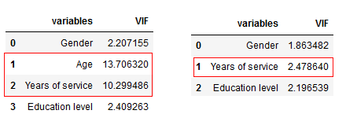

In our example, after dropping the ‘Age’ variable, VIF values for all variables have decreased to varying degrees.

Next, combine the correlated variables into one and drop the others. This will reduce the multicollinearity.